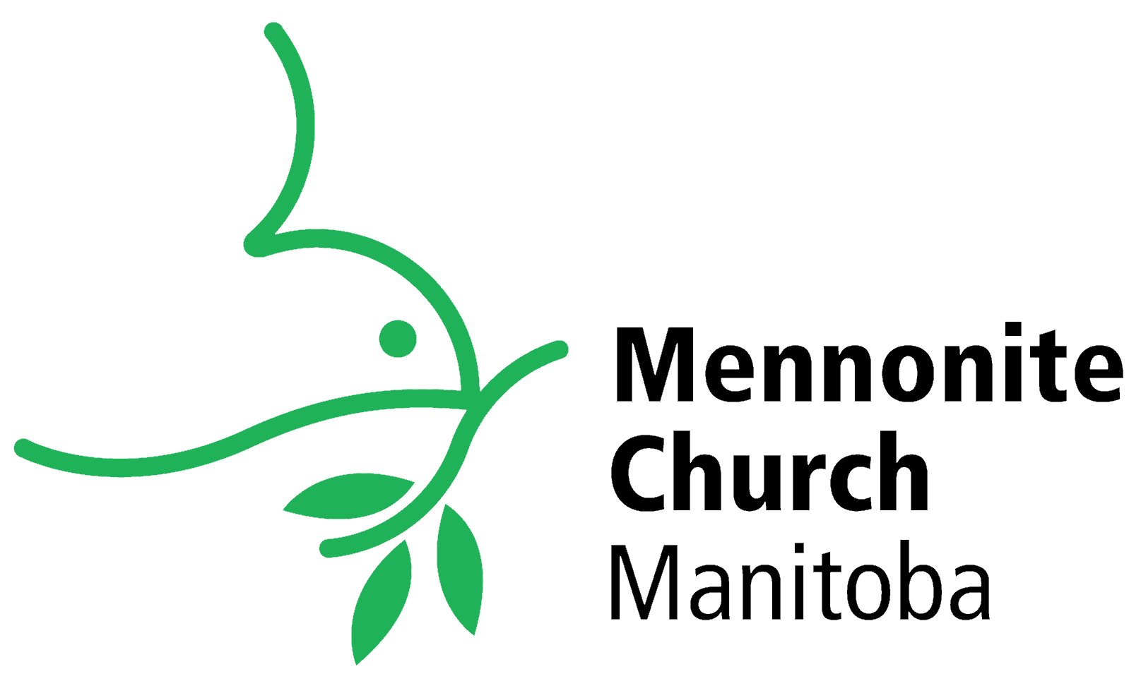
Mennonite Church Manitoba 2021: Year in Review
Mennonite Church Manitoba (www.mennochurch.mb.ca) is a community of 38 member congregations with almost 7,000 individual members. We gather throughout the province of Manitoba in the territories of Treaties 1, 2, 3, and 5, the homelands of diverse Indigenous peoples. We covenant together to follow Jesus and live out the call of Christ within an Anabaptist perspective. We also covenant together with our partner regional churches of MC British Columbia, MC Alberta, MC Saskatchewan, and MC Eastern Canada as Mennonite Church Canada (www.mennonitechurch.ca), to be a nationwide church that extends God’s love to our neighbours locally, nationally, and globally.

Another COVID Year
2021 will be remembered as “2020 2.0.” The COVID-19 pandemic has continued to ravage the globe, and this has had significant impact on our congregations and pastors as well as our collective ministry as MCM. Pastors are exhausted, programs are scaled back, budgets are tight, and congregations are left wondering who is still part of their fellowship and what their church will look like on the other side of the pandemic. The same realities are true for us as a regional church. Nevertheless, God has been at work among us! Read on for good news of the Spirit’s movement within MCM.

Camps with Meaning
Our Camps with Meaning (www.campswithmeaning.org) leaders and staff have done a tremendous job navigating the public health orders to provide a scaled-back summer camp program alongside retreat and rental opportunities. In 2021 we offered seven pop-up camps (4 for youth and 3 for adults with disabilities) at our campsites and churches, and five day camps (1 week at Koinonia, 4 at Assiniboia). We had close to 250 total campers served by 51 total staff. Summer campers played, ate, sang, and learned together around the theme, “Heroes of the Faith.”

Support for Pastors and Congregations
MCM staff have visited and walked alongside pastors and congregations in various ways, in person when possible, via phone or Zoom when necessary. Pastor cluster groups have continued to meet, complementing the individual support provided by staff. Staff have worked with church councils and search committees to find interim or long term pastors. Several pastors completed a credentialing process with MCM during 2021, and staff were delighted to participate in installation and ordination services virtually or in person. MCM staff also provide support for congregations in faith formation, worship, congregational care, and local mission, as well as misconduct response, conflict mediation, and resourcing for church councils.

Re-Focused Programs
The range of programs we offer as MCM was reviewed in 2021, leading to a shift in our programs and staffing. Our four primary program areas are now Leadership Ministries (overseen by Rick Neufeld), Congregational Ministries (Kathy Giesbrecht), Mission Ministries, and Camps with Meaning. Dorothy Fontaine is shifting from Director of Mission to Director of Camps with Meaning as of January 1, 2022, and we will be hiring a Director of Mission Engagement to oversee our Mission Ministries as well as to focus on church engagement. In addition, a new Congregational Health Committee has been formed to advise and support Kathy Giesbrecht in the area of Congregational Ministries, looking at ways to increase the health and vitality of our congregations.

New Working Groups
Two new MCM working groups are being added to our MCM Palestine-Israel Network and Woven (Mennonite Women Together). The Manitoba Mennonite Coalition for Indigenous Solidarity (MMCIS) will help our congregations to collaborate regionally for learning and action in solidarity with our Indigenous neighbours, and the MCM Climate Action Working Group (MCM CAWG) will do the same for our congregations related to our response to climate change.

Our Nationwide Ministry
Just as our ministry as congregations extends beyond our communities as Mennonite Church Manitoba, so our ministry as a regional church extends beyond our province as Mennonite Church Canada. Together with our other regional churches, we provide resourcing for MC Canada congregations and others through our CommonWord resource centre and website (www.commonword.ca). We have worked together in Indigenous-Settler Relations toward living out our commitments to truth and reconciliation. We work with International Witness partners around the world in over a dozen different countries to help bring Jesus’ ministry of reconciliation to life in these contexts. We are also committed to significant action nationwide in response to the climate crisis.

Moving Forward
We have two staff exits expected for 2022. Rick Neufeld will be retiring as Director of Leadership Ministries at the end of March, and David Hogue will be likewise be leaving as Site Manager at Camp Assiniboia at the end of April. We are grateful for their ministry among us and wish them well.
We are anticipating our MCM Gathering on March 5. Given the uncertainties in Manitoba related to COVID, this will once again be via Zoom. We are also anticipating our MC Canada Gathering in Edmonton from July 29 to August 1. We encourage all who are able to join us for these events.
2022 looks to be another year of challenge and change, yet with the Spirit of God working in us, among us, and through us in the world. At this point it looks to be “2020 3.0,” another year of pandemic. This will continue to create challenges for us as congregations and pastors, and as a regional church. We will face those challenges as we have so far: with an abiding faith in God, with courageous hope for God’s goodness to be shown among us, and with a deepening love for one another and for all, especially the most vulnerable of our world.
Michael Pahl
Executive Minister, Mennonite Church Manitoba

